Lab: Jupyter Notebooks - The Basics

We are using the Anaconda, a free and open-source distribution of the Python and R programming languages for scientific computing.

1. Please download and install the Python 3.x version of Anaconda for your operating system using the following link:

<https://www.anaconda.com/distribution/#download-section>

*Note: Since Jupyter Lab will replace Jupyter Notebooks in the long run we’re directly starting using Jupyter lab here. Don’t worry, the Jupyter notebook functionality is included, therefore you can use a pure Jupyter Notebooks as well.*

1. Once installation has finished, please start the application “anaconda-navigator”. It depends on your operating system on how to do this. From the navigator, please click on “Install” on the Jupyter Lab tile.

1. Once this has finished, you can “Launch” Jupyter Lab from the same tile.

This opens the Jupyter Lab user interface in your browser. From there, please click on the file explorer and select a folder where you want to store your Notebooks in.  
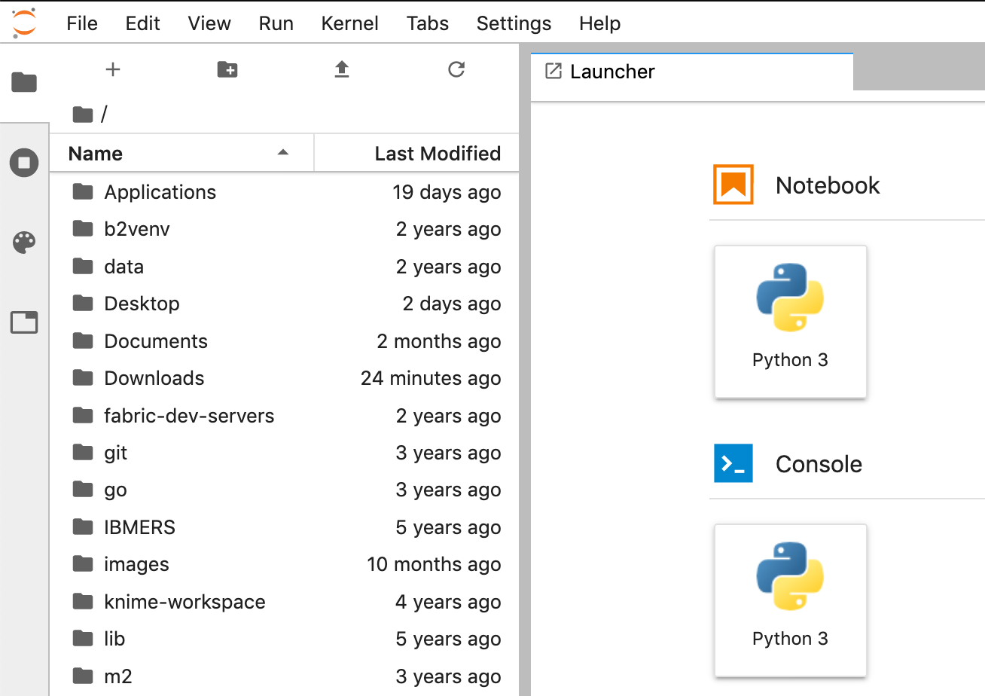 

1. In the launcher, please click on the “Python 3” tile under “Notebook”
2. In the Notebook’s first cell, please type  
   import sys  
   sys.version  
   A screenshot of a social media post

   Description automatically generated
3. Then click on the “Play” button. You should see an output as in the figure above.